Mech 368 Lab 3

Thomas Richmond, 52228848

21 October 2021

# Exercise 1

*Construction performed according to lab manual*

# Exercise 2

## Goals

* Implement an op-amp

## Setup



The MCP6002 circuit diagram was obtained from the datasheet and is shown on the right.



To achieve given an input voltage of 5V, we get the following relation:

Let’s use a standard resistor value of . The circuit is created as shown:

## Data

The output from is measured using the oscilloscope. The trace is shown below.

The trace is very steady with a nominal voltage of 2,5V.

# Exercise 3

## Goals

* Understand the principle of a strain gauge using a mock-up

## Setup

## Data

The signals traces for and are very stable. At a point in time, we see the following output:

We see the signal is within one major division, corresponding to a difference in signals of

which is compliant with the requirements of this exercise.

# Exercise 4

## Goals

* Analyze a Wheatstone bridge

## Setup

The questions posed in the exercise are answered below:



*Work shown on next page*









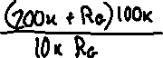

## Data

The signal amplification is calculated from the following trace, given the blue trace is for the strain gauge and the yellow trace is the amplifier output voltage .

Using the voltmeter function of the AD2, we find the following data:

|  |  |
| --- | --- |
| **Data** | **Value [mV]** |
|  | 3974 |
|  | 2502 |
|  | 2488 |
|  | 2495 |

Plugging these values into the equation above yields which is very close to our target value!

The no-load and maximum-load outputs are measured to be 2604mV and 3031mV, respectively. The difference in measurements is 427mV, which is commensurate with the values in the lab report.

# Exercise 5

## Goals

* Implement an offset amplifier to generate a reference voltage

## Setup



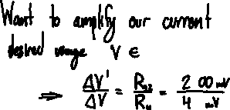

## 



The circuit was tuned from the initial setup above such that the final nominal resistance of resistor series is .

The final circuit setup is as shown:

With annotations:

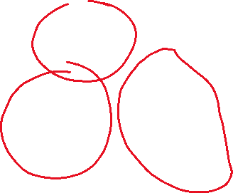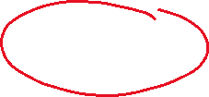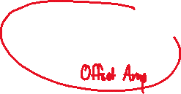

## Data

The no-load and maximum-load outputs are measured to be 2498mV and 460mV, respectively. This commensurate with the respective datapoints of 2500mV and 500mV as listed in the lab report.

# Exercise 6

## Goal

* Develop a program to visualize

## Setup

The code used was largely the same as from Lab 2 Exercise 6, with some minor modifications.

## Data

The output for the program is seen below. The graph contains some troughs, corresponding to probing of the load cell with my finger.

The code for Exercise 6 is further developed in Exercise 8. Refer to Appendix A for the code for Exercise 8 (code contained for this exercise is embedded therein)

# Exercise 7

## Goal

* Fit a trendline to a load cell to convert voltage to load

## Setup

A trendline is developed by placing a variety of weights onto the load cell and recording the voltage output from the offset amplifier. This is performed using Excel.

## Data

The datapoints 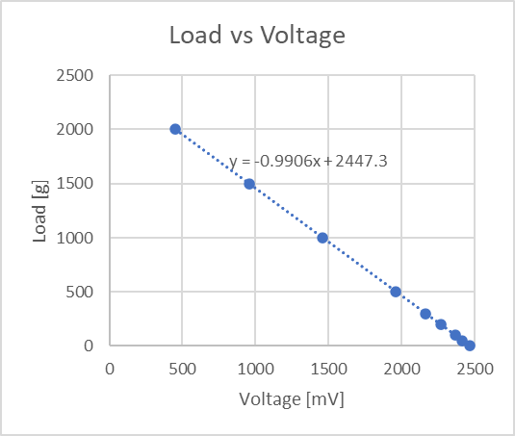are plotted on a scatterplot and a trendline is fitted. A slope of is obtained.

|  |  |
| --- | --- |
| **Load [g]** | **Voltage [mV]** |
| 0 | 2473 |
| 50 | 2418 |
| 100 | 2369 |
| 200 | 2270 |
| 300 | 2167 |
| 500 | 1965 |
| 1000 | 1461 |
| 1500 | 956 |
| 2000 | 452 |

# Exercise 8

## Goal

* Develop a UI to display load from a load cell
* Implement a stability detection algorithm

## Setup

The code from Exercise 6 is modified slightly to incorporate the following features:

* The average voltage is multiplied by the slope above to generate a load reading
* Tare functionality is added in two ways:
  + A tare button is added to the UI, allowing for the user to tare the scale at any time
  + The tare is automatically set the first time a signal is read by the program
* A stability detection algorithm is implemented; the algorithm generates a standard deviation over the last five hundred milliseconds, and if it is below 10 (empirically determined) then the reading is considered stable

## Data

The program functions very well. When the load cell is loaded to 500g the load is reported to be between 498 and 502 grams, falling within 1% error.

# Appendix A: Exercise 8 Code

|  |
| --- |
| using System;  using System.IO;  using System.IO.Ports;  using System.Windows.Forms;  using System.Collections.Generic;  using System.Collections.Concurrent;  using System.Windows.Forms.DataVisualization.Charting;  namespace Mech368Lab2E6  {  public partial class Mech368L3E6 : Form  {  enum AD2Token  {  PACKET_HEADER = 0xFF,  STREAM_REQUEST_ACCELEROMETER = 'A',  STREAM_REQUEST_THERMISTOR = 'c',  LED5_ON = '5',  LED5_OFF = '%'  }  private ConcurrentQueue<int> streamBuffer;  private SerialPort port;  private StreamWriter streamWriter;  private Series loadvoltages;  private Series loads;  private double load = 0;  private double tare = double.NaN;  public Mech368L3E6()  {  InitializeComponent();  InitializeListeners();  this.streamBuffer = new ConcurrentQueue<int>();  this.port = this.BindSerial();  this.port.Write(((char)AD2Token.STREAM_REQUEST_THERMISTOR).ToString());    this.loadvoltages = new Series("Load Voltages");  this.loadvoltages.ChartType = SeriesChartType.FastLine;  this.loadvoltages.YValueType = ChartValueType.Double;  //plot.Series.Add(this.loadvoltages);  this.loads = new Series("Load");  this.loads.ChartType = SeriesChartType.FastLine;  this.loads.YValueType = ChartValueType.Double;  plot.Series.Add(this.loads);    //this.tareBtn.Visible = false;  //this.stabilityLabel.Visible = false;  //this.loadTB.Visible = false;  //this.label3.Visible = false;  //this.label4.Visible = false;  }  private void InitializeListeners()  {  this.filepathTB.Click += this.ConfigureOutputStream;  this.savetofileCB.CheckedChanged += this.ToggleFilewriter;  this.processLoop.Tick += this.ProcessDatastream;  this.processLoop.Tick += this.DetectStability;  this.tareBtn.Click += this.SetTare;  }    private SerialPort BindSerial()  {  SerialPort p = new SerialPort()  {  PortName = "COM3",  BaudRate = 9600,  Parity = Parity.None,  DataBits = 8,  StopBits = StopBits.One,  Handshake = Handshake.None  };  p.DataReceived += this.CaptureDatastream;  p.Open();    return p;  }  private void ConfigureOutputStream(object sender, EventArgs e)  {  SaveFileDialog sfd = new SaveFileDialog();  if (sfd.ShowDialog() == DialogResult.OK)  filepathTB.Text = sfd.FileName;  }  private void ToggleFilewriter(object sender, EventArgs e)  {  if (this.streamWriter == null)  if (this.filepathTB.Text.Length > 0)  this.streamWriter = new StreamWriter(this.filepathTB.Text);  else  MessageBox.Show("Invalid filename!");  else  {  this.streamWriter.Close();  this.streamWriter = null;  }  }  private void OnFormClosing(object sender, EventArgs e)  {  if (this.port != null && this.port.IsOpen)  this.port.Close();  if (this.streamWriter != null)  this.streamWriter.Close();  }  private void CaptureDatastream(object sender, EventArgs e)  {  int next; // Byte buffer  try  {  while ((next = this.port.ReadByte()) != -1)  this.streamBuffer.Enqueue(next); // ConcurrentQueue buffer implementation  }  catch { /*Ignored!*/ }  }  Queue<int> circularBuffer = new Queue<int>();  private void ProcessDatastream(object sender, EventArgs e)  {  void EnqueueCircular(Queue<int> queue, int next, int max)  {  queue.Enqueue(next);  if (queue.Count > max)  queue.Dequeue();  }  int AverageQueue(Queue<int> queue, int offset = 0)  {  float avg = 0;  foreach (int val in queue)  avg += val - offset;  avg /= (float)queue.Count;  return (int) Math.Round(avg);  }  int signal = -1;  while (this.streamBuffer.TryDequeue(out int next))  {  if (next == (int)AD2Token.PACKET_HEADER)  {  if (signal == -1)  {  signal = 0;  continue;  }  double discretized = signal / ((double)(2 << 9));  int nextVoltage = (int) (discretized * 3600);  EnqueueCircular(this.circularBuffer, nextVoltage, 50);  int avgVoltage = AverageQueue(this.circularBuffer);  voltageTB.Text = nextVoltage.ToString();  voltageAvgTB.Text = avgVoltage.ToString();// avgVoltage.ToString();  this.loadvoltages.Points.AddY(nextVoltage);  double nextLoad = avgVoltage * -0.9906;  if (double.IsNaN(this.tare))  this.tare = nextLoad;  nextLoad -= tare;  loadTB.Text = nextLoad.ToString();  this.loads.Points.AddY(load);  if (this.streamWriter != null)  this.streamWriter.WriteLine(  $"{DateTime.Now.ToString("hh.mm.ss.ffffff")}, "  + $"{nextVoltage}, "  + $"{avgVoltage}, "  + nextLoad.ToString("0.##"));    this.load = nextLoad;  signal = 0;  continue;  }  else if (signal == -1) // Haven't captured a packet header  continue;  else // Assemble bytes  signal = (signal << 5) + next;  }  }  private void DetectStability(object sender, EventArgs e)  {  double SumSquaresQueue(Queue<int> queue)  {  float summed = 0;  foreach (int val in queue)  summed += val * val;  return summed;  }  double AverageQueue(Queue<int> queue, int offset = 0)  {  float avg = 0;  foreach (int val in queue)  avg += val - offset;  avg /= (float)queue.Count;  return avg;  }  double sum = SumSquaresQueue(this.circularBuffer);  double mean = AverageQueue(this.circularBuffer);  double stdev = Math.Sqrt(sum / ((double)this.circularBuffer.Count) - mean * mean);  //this.filepathTB.Text = stdev.ToString();  this.stabilityLabel.Text = stdev < 10 ? "STABLE" : "UNSTABLE";  }  private void SetTare(object sender, EventArgs e)  {  this.tare = this.load + this.tare;  }  }  } |